SUPERSTORE SALES PERFORMANCE ANALYSIS

Prepared by: Yuvraj Grewal
Role: Data Analyst Intern
Tools Used: Excel, SQL, Power BI
Date: July 2026

Executive Summary
This report analyzes Superstore sales performance using Excel, SQL, and Power BI. The analysis focuses on sales, profit, quantity, regional performance, state-wise sales, customer segments, and category performance. The objective is to identify business insights and provide recommendations for improving business performance.

Objectives
Analyze sales performance.
- Identify the most profitable regions.
- Compare category performance.
- Study customer segments.
- Provide business recommendations.

CATEGORY PERFORMANCE ANALYSIS
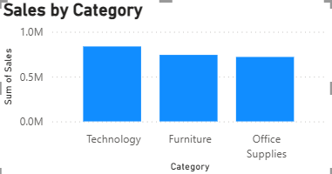
Key Findings
• Technology generated the highest sales.
• Furniture ranked second in sales.
• Office Supplies generated the lowest sales. .
Recommendations
• Increase inventory for the highest-selling category.
• Improve marketing for lower-performing categories.
• Offer bundle discounts to increase cross-category sales.
• Monitor category performance regularly

REGION PERFORMANCE ANALYSIS

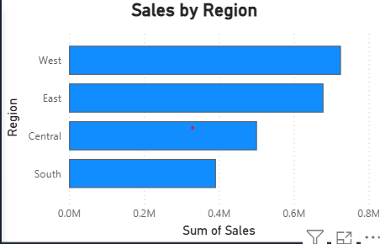
Key Findings
- West region recorded the highest sales.
- East region ranked second.
- Central region showed moderate sales.
- South region had the lowest sales.
Recommendations
• Increase marketing in low-performing regions.
• Replicate successful sales strategies from the highest-performing region.
• Improve customer engagement in weaker regions.
• Monitor regional performance regularly.

STATE PERFORMANCE ANALYSIS

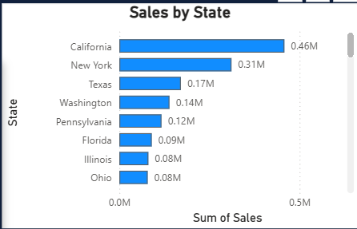

Key Findings
• California recorded the highest sales.
• New York ranked second in sales.
• Texas is among the top-performing states.
• Sales gradually decline after the top three states

Business Insight
Sales are concentrated in a few high-performing states. Expanding successful sales strategies to lower-performing states could improve overall business performance.

Recommendations
- Increase marketing efforts in low-performing states.
- Focus inventory on high-demand states.
- Analyze customer behavior in top-performing states.
- Develop targeted campaigns for states with lower sales.

CUSTOMER SEGMENT & SALES TREND ANALYSIS
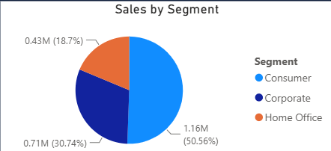
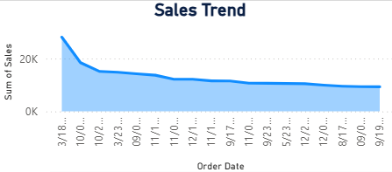

Customer Segment Insights
- Consumer segment contributes the highest share of total sales.
- Corporate segment is the second-largest contributor.
- Home Office contributes the least.

Sales Trend Insights
- Sales fluctuate throughout the period.
- Some months show significantly higher sales than others.
- The trend helps identify peak and slow sales periods.

Recommendations
- Focus marketing campaigns on the Consumer segment.
- Improve offers for Corporate and Home Office customers.
- Prepare inventory before peak sales periods.
- Run promotions during slower months.

DASHBOARD OVERVIEW & KEY FINDINGS
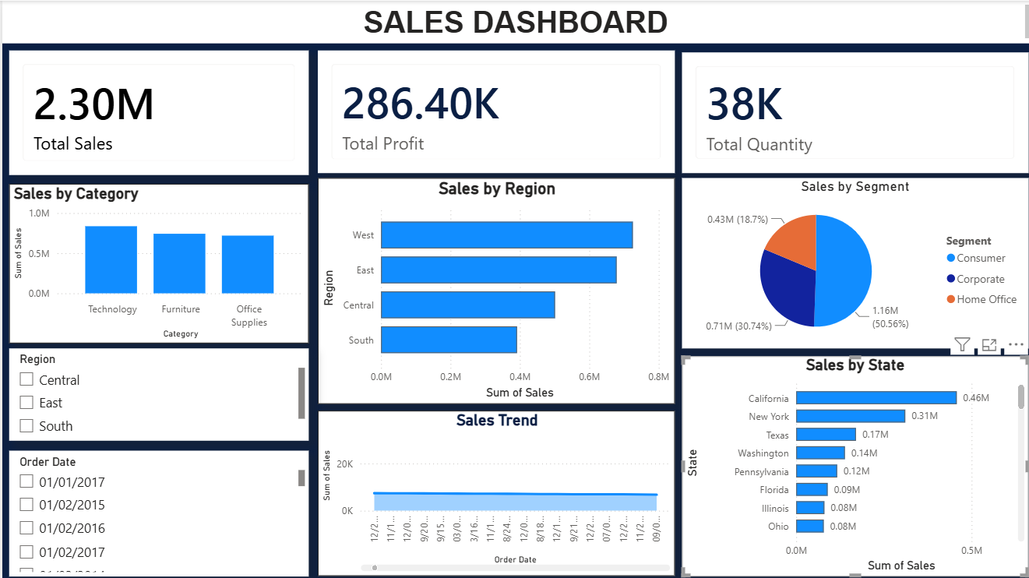

Key Findings
- Total Sales: ₹2.30 Million
- Total Profit: ₹286.40 Thousand
- Total Quantity Sold: 38 Thousand Units
- Technology category generated the highest sales.
- West region performed better than the other regions.
- Consumer segment contributed the largest share of sales.
- California was among the top-performing states.
- The dashboard allows users to analyze sales interactively using filters.

- Focus marketing campaigns on high-performing categories.
- Increase sales efforts in low-performing regions.
- Expand successful strategies from top-performing states.
- Use dashboard insights for monthly business reviews.
- Monitor sales trends regularly to improve forecasting.
- Continue using data-driven decision-making for business growth.

Conclusion
This project successfully analyzed the Superstore dataset using Excel, SQL, and Power BI. Interactive dashboards helped identify key sales trends, regional performance, customer segments, and product categories. The insights generated through this analysis can support better business decisions, improve profitability, and enhance overall sales performance. This project also strengthened practical skills in data cleaning, SQL querying, data visualization, and business analytics.

